REQUIREMENT ANALYSIS

Technology stack (Architecture & Stack)

Date | FEB 2026
Team ID | SBAP0031863
Project Name | ToyCraft tales: tableau's vision into toy manufacturer data
Maximum Marks | 4 Marks

Technical Architecture
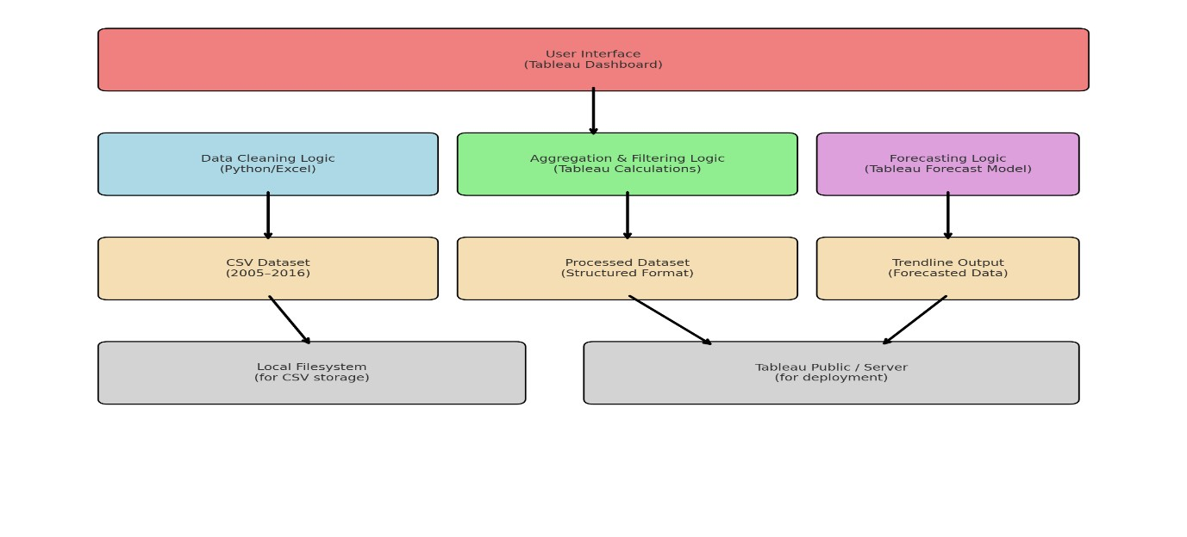
Table-1 : Components & Technologies:
S.No | Component | Description | Technology
1. | User Interface | Dashboard interface for users to interact with data | Tableau Public
2. | Application Logic-1 | Data cleaning and transformation | Excel(pre-Tableau)
3. | Application Logic-2 | Data aggregation by year, category, region | Tableau calculated fields
4. | Application Logic-3 | Forecasting based on historical trends | Tableau Forecasting
5. | Database | CSV dataset with shipment and category info | Excel sheet
6. | Cloud Database | Not applicable | Tableau cloud
7. | File Storage | Upload and store toy dataset | Local drives or google drive
8. | External API-1 | Weather data to correlate seasonality | Open WeatherAPI
9. | External API-2 | Social media trend integration | Google Trends
10. | Machine Learning Model | Predictive modeling | Tableau’s built-in forecast model
11. | Infrastructure (Server /  Cloud) | Cloud-hosted dashboard viewable by users | Tableau Server/Tableau public

Table-2: Application Characteristics:
S.No | Characteristics | Description | Technology
1. | Open-Source  Frameworks | Python (data cleaning) | Python
2. | Security  Implementations | Restricted access via Tableau login | IAM (Tableau server)
3. | Scalable Architecture | Tableau scales to multiple dashboards/users without code changes | Tableau cloud Architecture
4. | Availability | Dashboard hosted on Tableau Public with 24/7 access | Tableau server/Tableau public
5. | Performance | Optimized visual queries, aggregated filters, and trendline calculations | Tableau filtering

